Real Time River Water Quality Monitoring and Control System Team ID : PNT2022TMID17030

Building Mobile App

Step 1: Design Your UI To Display The Water Turbidity, PH Values

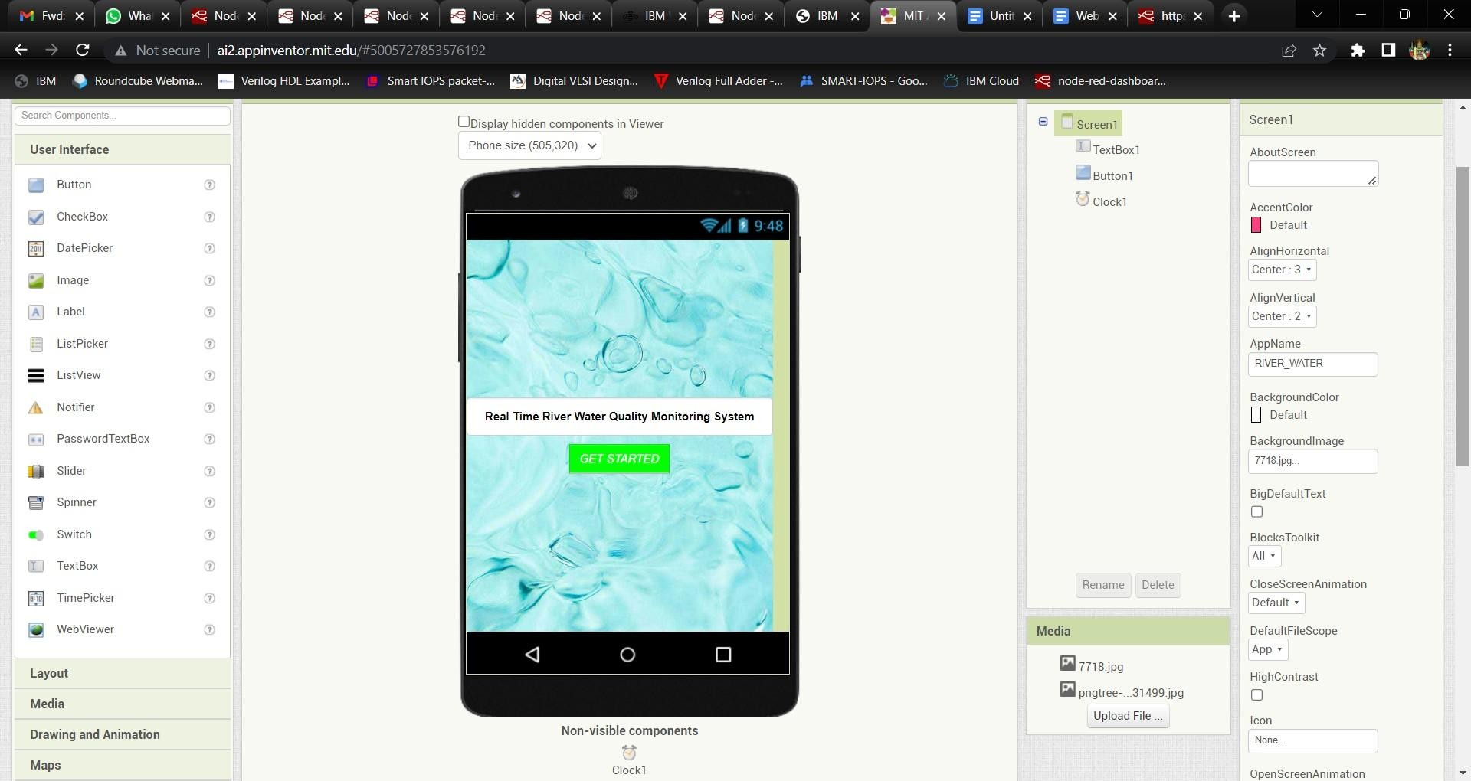

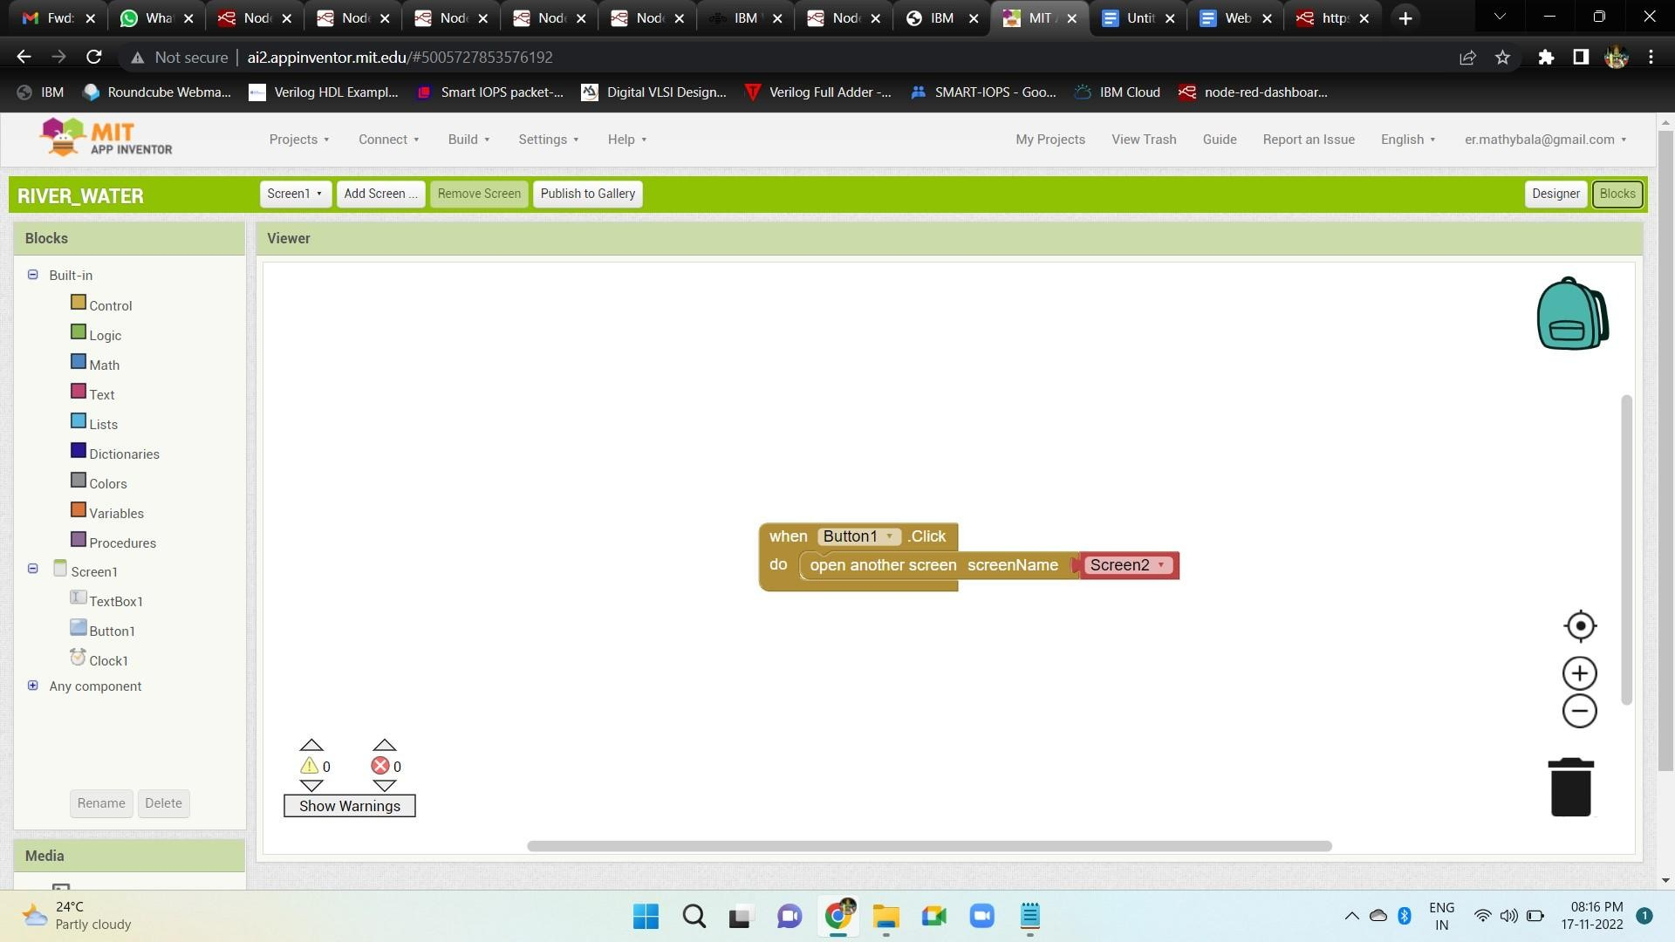

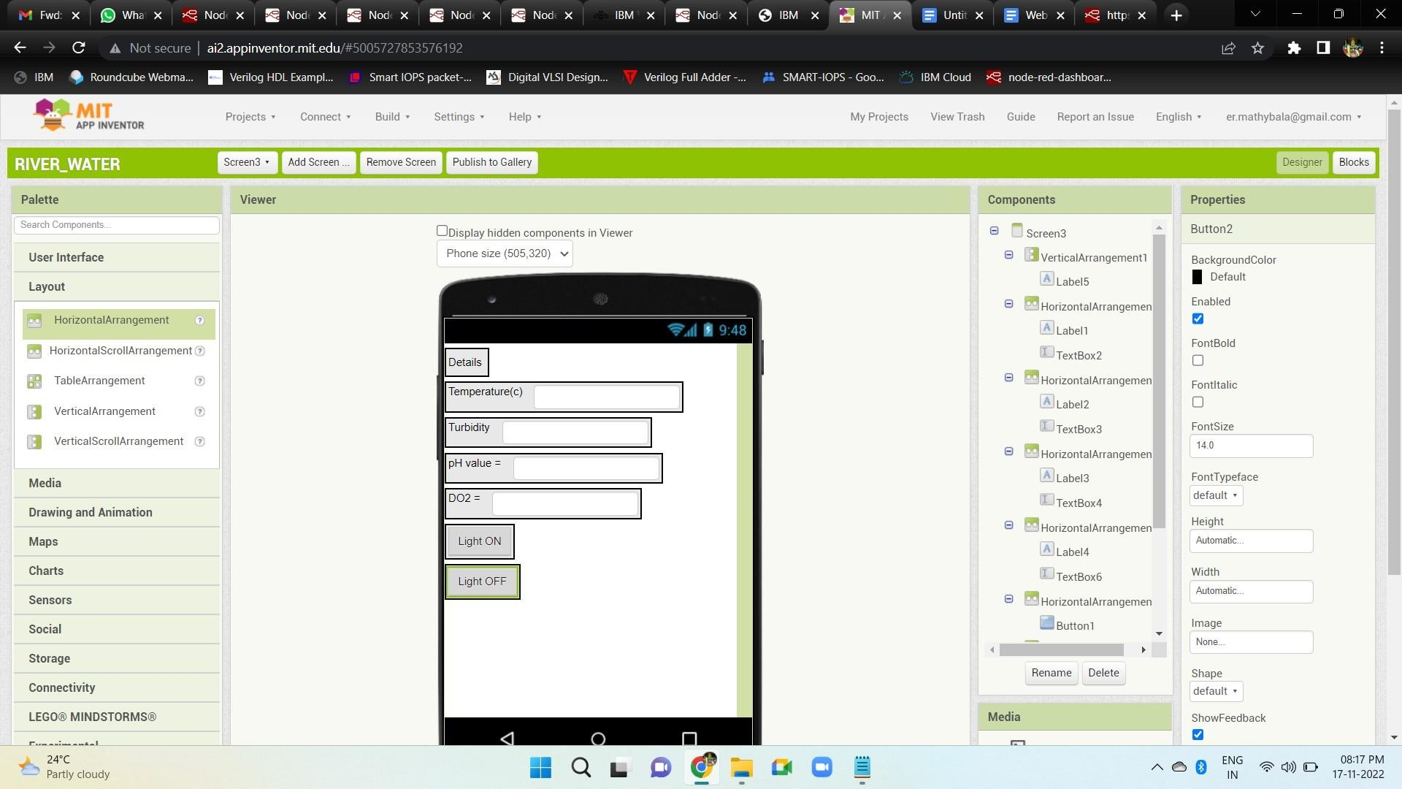

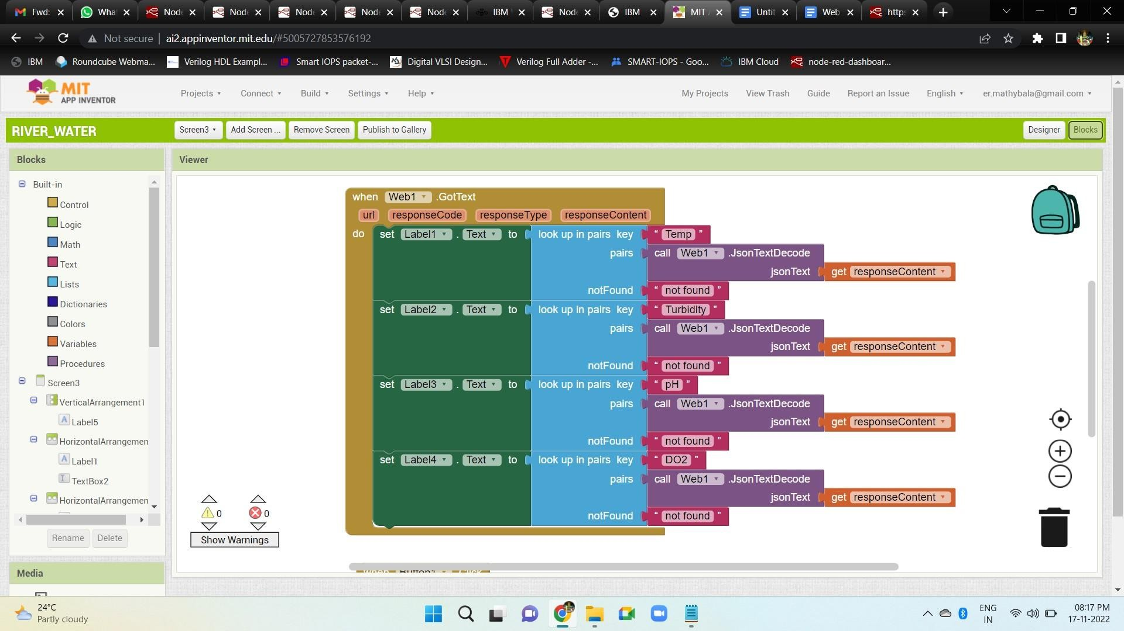

Step 2: Configure The Application To Receive The Data From Cloud.

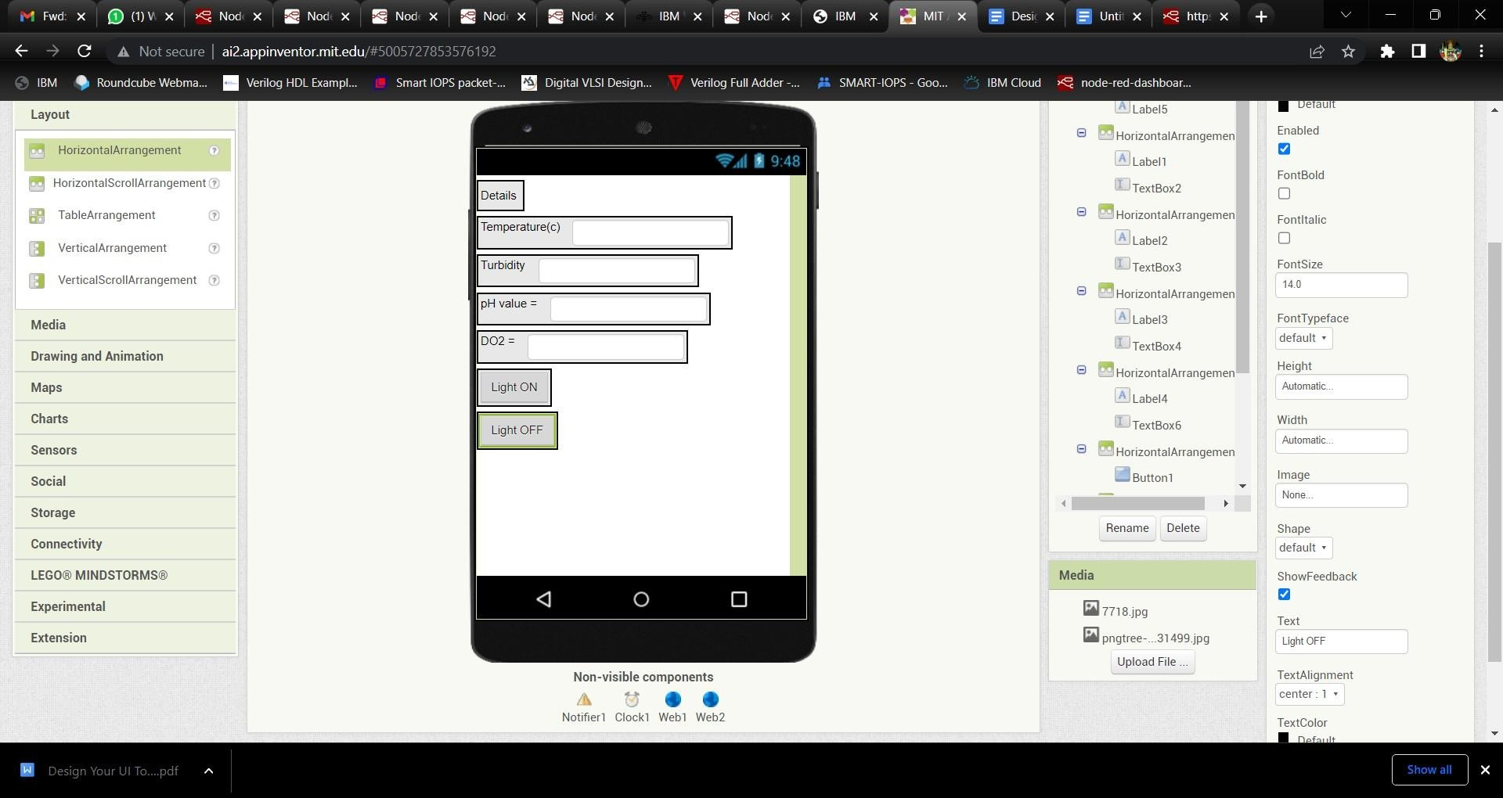

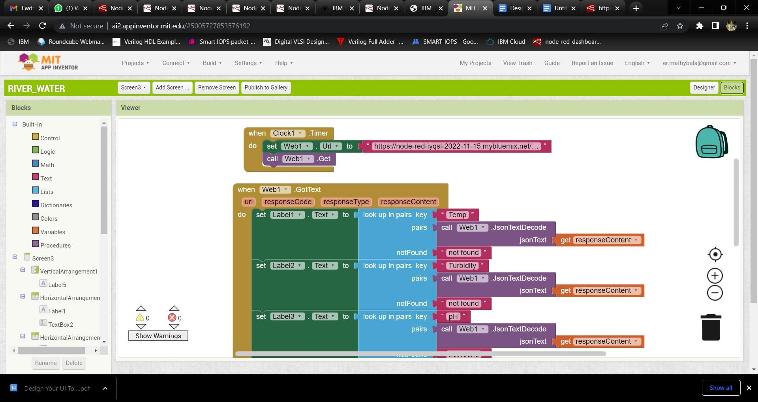

Step 3: Configure The Mobile App For Controlling Motor Using Buttons.



